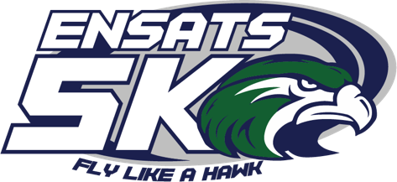

Homecoming 5K Cross Country Race

Saturday October 23,2021

Walk 9:00/ Shotgun Start 9:30am
Hosted by: Essex North Shore Class of 2022
Thank you for your support!

Your donation will provide funds for Senior Class events, as well as, Scholarships for Essex North Shore Agricultural and Technical School graduates. In addition, sponsorship will help defray the cost of organizing this event. Funds received from sponsors will purchase t-shirts, complimentary food and beverages for participants, timing for the event, and awards. Additional funds raised will be used to help reach our goal of providing scholarships and supporting senior activities.

Sponsorship Amounts:
☐ $1000.00 Title Sponsor (max of three per event)
Benefits to sponsor:
- Company Logo on the race website and news releases
- Promotion during race day announcements
- Large logo across back of participant t-shirt
- Table for promotion during event
- Company name/Logo on event banner
- Up to 5 Complimentary Registrations

☐ $500 Gold Level Sponsor
Benefits to sponsor:
- Company Name listed on website
- Promotion during race day announcements
- Company Name listed on T-Shirt
- Table for promotion during event
- Up to 3 Complimentary Registrations

☐ $300 Silver Level Sponsor
Benefits to sponsor:
- Company Name listed on website
- Company Name listed on T-Shirt
- Mile Marker Sponsorship
- 1 Complimentary Registration

☐ $100 Bronze Level Sponsor
- Company Name listed on T-Shirt
____________________________________________________________________________________________________________
Please complete this form and email to MBerry@essextech.net
Company Name: _______________________________________________________________________________
Address: _____________________________________________________________________________________
City: _________________________State: __________ Zip code: __________________
Contact Person: __________________________________________________________
Contact Email: ___________________________________________________________
Phone Number: __________________________________________________________
Website Address:_________________________________________________________
Sponsorship Level: ____Title Sponsor ____Gold Sponsor _____Silver Sponsor ____Bronze Sponsor
Please write your company name exactly how you would like it to appear on website and news releases: ______________________________________________________________________________________

We are unable to sponsor this event but would like to give a donation: Other Donation Amount: _______________________

Checks can be made payable to Essex North Shore 5K and mailed to:
Student Activities/ 5K Sponsorship; 565 Maple Street, Hathorne, MA 01937

For additional questions or information please contact Marissa Berry at (978) 304-4700 or email to mberry@essextech.net

